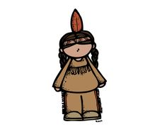
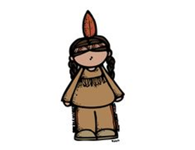
Native Peoples Museum

IB Central Idea: Identifying, using, and describing patterns help to understand relationships within nature and cultures.
Standard SS4H1-The student will describe how native cultures developed.
- Locate where the natives settled.
- Describe how the natives used their environment to obtain food, clothing, and shelter.

****DUE: Friday, Sep. 30th****
Now it is your turn to show what you have learned in class about the Native American group of your choice! You are the curator of a new exhibit opening at a museum. Use your research of your Native American tribe to create a display for our Museum Walk on Friday, September 30th. Your exhibit must include details about the tribes region, climate, food, clothing, and shelter. Your project MUST be ready and at school by the morning of Friday Sept. 30. Feel free to use your creativity to display your research in any way you would like. However, you may not complete a PowerPoint because we have already completed one in class. You may, instead, create a diorama, poster or 3D display! Use the rubric on back to guide you. Most importantly, HAVE FUN WHILE YOU SHOW YOUR LEARNING

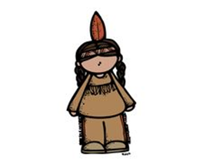
Native Peoples Rubric

Name ____________________________________ # ________
 | 20 points | 15 points | 10 points | 0 points
Region | Region is clearly displayed and labeled. | Region is mostly displayed and labeled. | Region is unclear and/or is not labeled. | Region is not evident.
Climate | Climate is clearly displayed and labeled. | Climate is mostly displayed and labeled | Climate is unclear and/or is not labeled. | Climate is not evident.
Food | Primary foods from region (3+) are displayed and are labeled. | Primary foods (2) from region are displayed and some are labeled. | Primary foods (1) from region are unclear and/or not labeled. | Primary foods are not evident.
Clothing | The native clothing is clearly displayed and all pieces are labeled. | The native clothing is mostly displayed and some pieces are labeled. | The native clothing is unclear and/or is not labeled. | The native clothing is not evident.
Shelter | The shelter is displayed and labeled. | The shelter is mostly displayed and/or is somewhat labeled. | The shelter is unclear and/or is not labeled. | The shelter is not evident.

Final Grade _______________/100 = ____________________

